General setup just before the workshop

On the top horizontal menu, go to: **Tools** - > **Global Options**

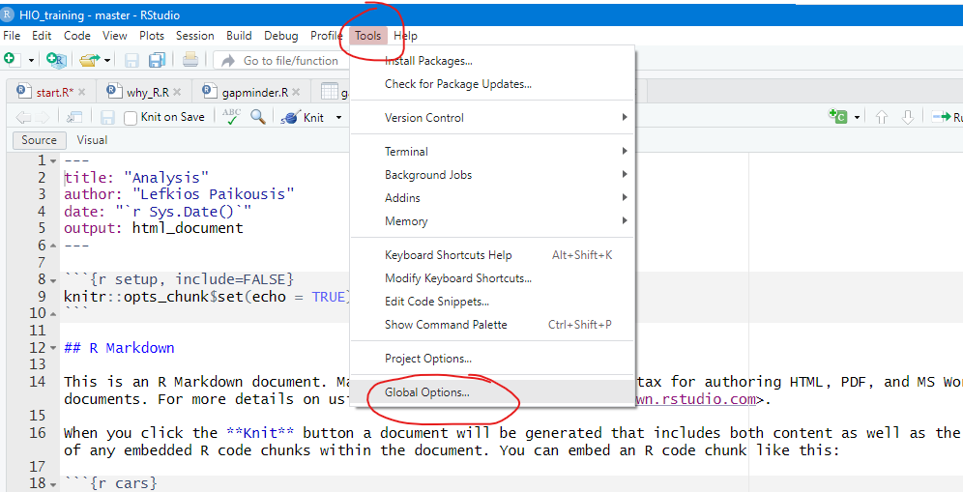

1. On the General Tab:

Make sure

* Restore .RData is NOT checked
* Save workspace to .RData on exit [NEVER] is selected
* HISTORY: All unchecked

1. On the Code Tab:

Make sure the `Use native pipe operator` is clicked.

1. On the Pane Layout tab

It is recommended that you put the `Console` pane, on the TOP-RIGHT panel

Just click on the TOP-RIGHT panel and select `Console`

